* 1. The k th moment of the power law distribution is

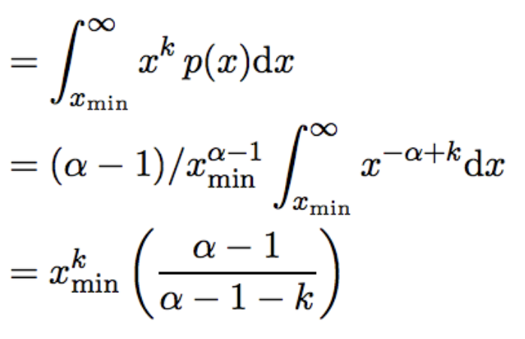

According to the definition of moments, the second moment is the variance. When αis between 2 and 3, the variance is infinite. Thus we can conclude that even though the expected value is finite, it is not a good estimator of the data since the variance is so large.



1. 2. Repository Name: homework-3-terrylu_kinaanpatel

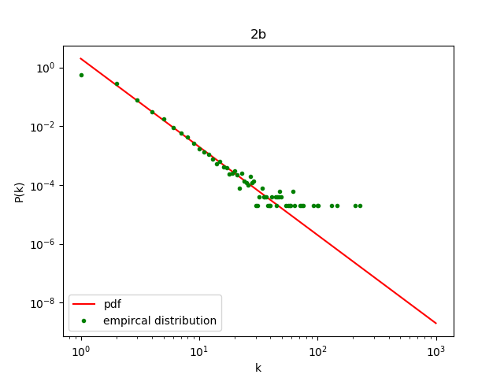



$P=Zk^{-α}$

$$\ln{P}=\ln{Z}-α\ln{k}$$

Let $β$ be the result of a linear regression of on

* + 1. Repository Name: homework-3-terrylu_kinaanpatel

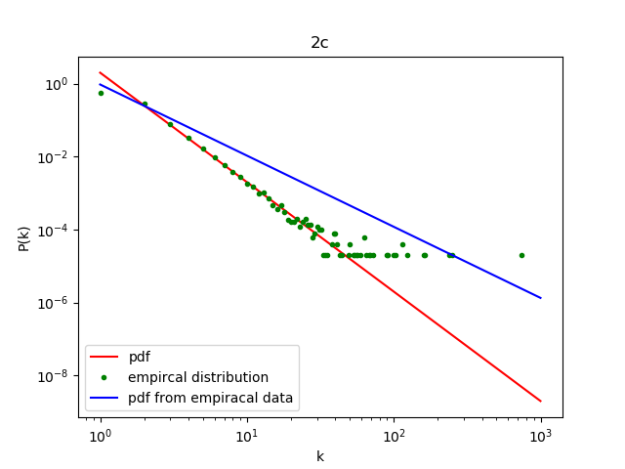

* + 1. This method produces a bad fit for $α$ because there is a minimum probability due to the number of points, and this causes points that occur that have large k values to have a probability much higher than what would be anticipated

$P=\frac{1}{k_{min}^{1-α}}k^{1-α}$

$$\ln{P}=\ln{\frac{1}{k_{min}^{1-α}}}+\left(1-α\right)\ln{k}$$

Let $β$ be the result of a linear regression of on

* + 1. Repository Name: homework-3-terrylu_kinaanpatel

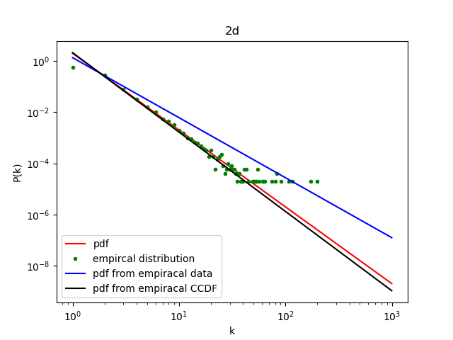

* 1. using pdf, average alpha = 2.21909439331

using pdf, standard deviation alpha = 0.166870329052

using ccdf, average alpha = 2.87928313183

using ccdf, standard deviation alpha = 0.382480866581

please refer to our code for detailed computation of the values. It is clear that ccdf is a better estimate of α. The average of pdf method is way too far away from 3.

* 1. BONUS:
     1. Repository Name: homework-3-terrylu_kinaanpatel

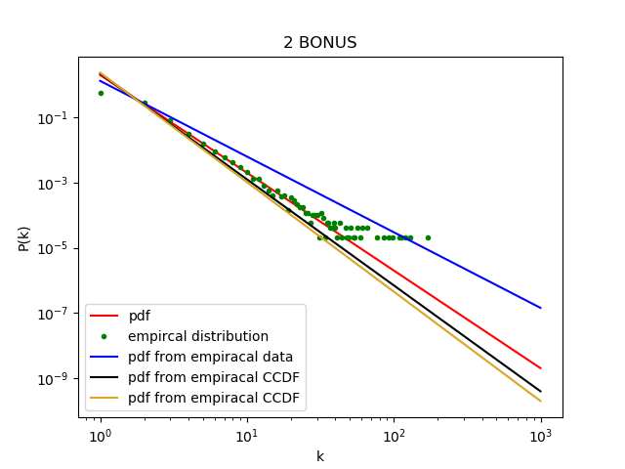

The mean estimate using MLE, 3.34178463954, is larger than the actual value 3, and is also larger than the average using ccdf method, 2.87928313183, and using pdf method, 2.21909439331. The standard deviation using MLE, 0.014035993224 is much lower than the standard deviation using Pdf, 0.166870329052, and it is also lower than the standard deviation using ccdf 0.382480866581.

1. 1. Repository Name: homework-3-terrylu_kinaanpatel

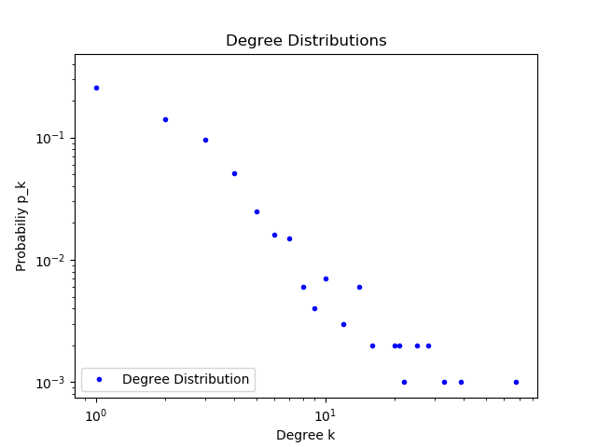

* 1. average alpha = 2.47375682356

standard deviation alpha = 0.0700854604155